Default Report  
*WTP For Green Electricity*  
**June 6th 2022, 1:11 pm CEST**

**Income - Aký je približný mesačný príjem Vašej domácnosti?**

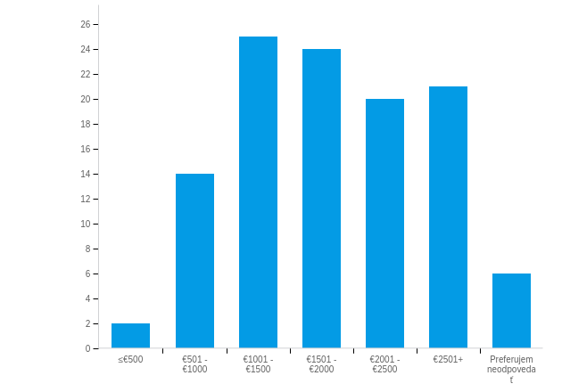

|  |  |  |  |  |  |  |  |
| --- | --- | --- | --- | --- | --- | --- | --- |
| # | Field | Minimum | Maximum | Mean | Std Deviation | Variance | Count |
| 1 | Aký je približný mesačný príjem Vašej domácnosti? | 1.00 | 7.00 | 4.19 | 1.50 | 2.26 | 112 |

|  |  |  |  |
| --- | --- | --- | --- |
| # | Answer | % | Count |
| 1 | ≤€500 | 1.79% | 2 |
| 2 | €501 - €1000 | 12.50% | 14 |
| 3 | €1001 - €1500 | 22.32% | 25 |
| 4 | €1501 - €2000 | 21.43% | 24 |
| 5 | €2001 - €2500 | 17.86% | 20 |
| 6 | €2501+ | 18.75% | 21 |
| 7 | Preferujem neodpovedať | 5.36% | 6 |
|  | Total | 100% | 112 |

**Energy Consumption - Viete, aké je Vaše sadzobné pásmo za spotrebu elektriny? (dotazník pokračuje aj keď zaškrtnete možnosť Nie)**

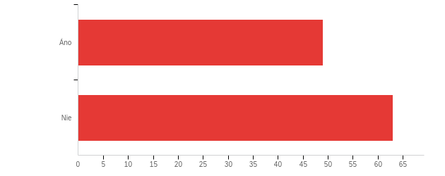

|  |  |  |  |  |  |  |  |
| --- | --- | --- | --- | --- | --- | --- | --- |
| # | Field | Minimum | Maximum | Mean | Std Deviation | Variance | Count |
| 1 | Viete, aké je Vaše sadzobné pásmo za spotrebu elektriny? (dotazník pokračuje aj keď zaškrtnete možnosť Nie) | 1.00 | 2.00 | 1.56 | 0.50 | 0.25 | 112 |

|  |  |  |  |
| --- | --- | --- | --- |
| # | Answer | % | Count |
| 1 | Áno | 43.75% | 49 |
| 2 | Nie | 56.25% | 63 |
|  | Total | 100% | 112 |

**Tariff - Zadajte Vaše sadzobné pásmo:**

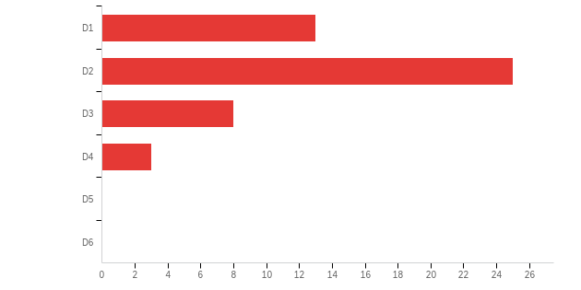

|  |  |  |  |  |  |  |  |
| --- | --- | --- | --- | --- | --- | --- | --- |
| # | Field | Minimum | Maximum | Mean | Std Deviation | Variance | Count |
| 1 | Zadajte Vaše sadzobné pásmo: | 1.00 | 4.00 | 2.02 | 0.82 | 0.67 | 49 |

|  |  |  |  |
| --- | --- | --- | --- |
| # | Answer | % | Count |
| 1 | D1 | 26.53% | 13 |
| 2 | D2 | 51.02% | 25 |
| 3 | D3 | 16.33% | 8 |
| 4 | D4 | 6.12% | 3 |
| 5 | D5 | 0.00% | 0 |
| 6 | D6 | 0.00% | 0 |
|  | Total | 100% | 49 |

**Region - Kde bývate?**

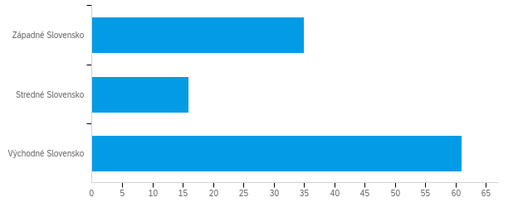

|  |  |  |  |  |  |  |  |
| --- | --- | --- | --- | --- | --- | --- | --- |
| # | Field | Minimum | Maximum | Mean | Std Deviation | Variance | Count |
| 1 | Kde bývate? | 1.00 | 3.00 | 2.23 | 0.90 | 0.80 | 112 |

|  |  |  |  |
| --- | --- | --- | --- |
| # | Answer | % | Count |
| 1 | Západné Slovensko | 31.25% | 35 |
| 2 | Stredné Slovensko | 14.29% | 16 |
| 3 | Východné Slovensko | 54.46% | 61 |
|  | Total | 100% | 112 |

**Appliances - Vyberte všetky spotrebiče, ktoré vlastníte (môžete zaškrtnúť viacero):**

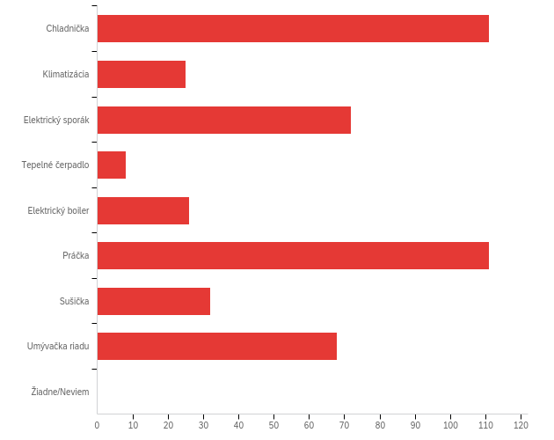

Data source misconfigured for this visualization

|  |  |  |  |
| --- | --- | --- | --- |
| # | Answer | % | Count |
| 1 | Chladnička | 24.50% | 111 |
| 2 | Klimatizácia | 5.52% | 25 |
| 3 | Elektrický sporák | 15.89% | 72 |
| 4 | Tepelné čerpadlo | 1.77% | 8 |
| 5 | Elektrický boiler | 5.74% | 26 |
| 6 | Práčka | 24.50% | 111 |
| 7 | Sušička | 7.06% | 32 |
| 8 | Umývačka riadu | 15.01% | 68 |
| 9 | Žiadne/Neviem | 0.00% | 0 |
|  | Total | 100% | 453 |

**Concern - Ako veľmi sa obávate, že produkcia elektrickej energie nenávratne poškodí prírodné prostredie?**

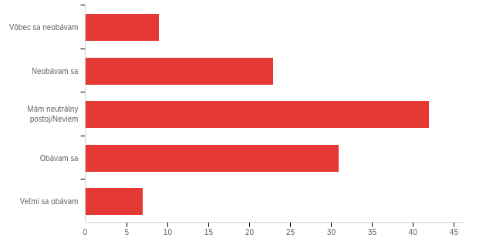

|  |  |  |  |  |  |  |  |
| --- | --- | --- | --- | --- | --- | --- | --- |
| # | Field | Minimum | Maximum | Mean | Std Deviation | Variance | Count |
| 1 | Moja obava | 1.00 | 5.00 | 3.04 | 1.03 | 1.05 | 112 |

|  |  |  |  |
| --- | --- | --- | --- |
| # | Answer | % | Count |
| 1 | Vôbec sa neobávam | 8.04% | 9 |
| 2 | Neobávam sa | 20.54% | 23 |
| 3 | Mám neutrálny postoj/Neviem | 37.50% | 42 |
| 4 | Obávam sa | 27.68% | 31 |
| 5 | Veľmi sa obávam | 6.25% | 7 |
|  | Total | 100% | 112 |

**RES_attitude - Myslíte si, že produkcia energie z obnoviteľných zdrojov (OZ) pomáha zlepšovať životné prostredie?**

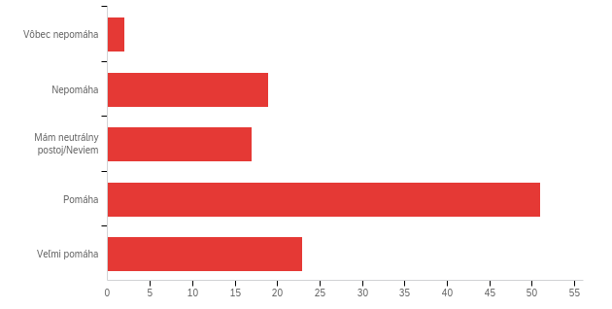

|  |  |  |  |  |  |  |  |
| --- | --- | --- | --- | --- | --- | --- | --- |
| # | Field | Minimum | Maximum | Mean | Std Deviation | Variance | Count |
| 1 | Produkcia z OZ ... | 1.00 | 5.00 | 3.66 | 1.04 | 1.08 | 112 |

|  |  |  |  |
| --- | --- | --- | --- |
| # | Answer | % | Count |
| 1 | Vôbec nepomáha | 1.79% | 2 |
| 2 | Nepomáha | 16.96% | 19 |
| 3 | Mám neutrálny postoj/Neviem | 15.18% | 17 |
| 4 | Pomáha | 45.54% | 51 |
| 5 | Veľmi pomáha | 20.54% | 23 |
|  | Total | 100% | 112 |

**Providers - Ktorých dodávateľov energie poznáte? (môžete zaškrtnúť viacero)**

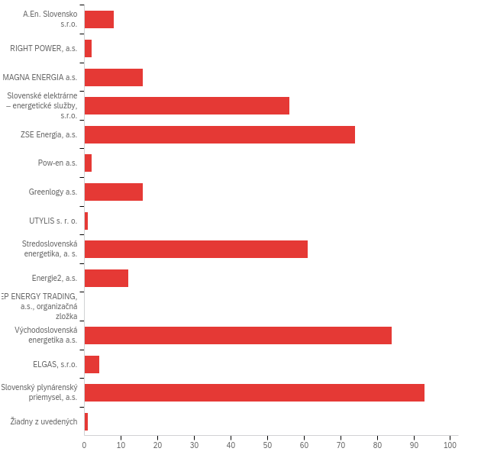

|  |  |  |  |
| --- | --- | --- | --- |
| # | Answer | % | Count |
| 1 | A.En. Slovensko s.r.o. | 1.86% | 8 |
| 2 | RIGHT POWER, a.s. | 0.47% | 2 |
| 3 | MAGNA ENERGIA a.s. | 3.72% | 16 |
| 4 | Slovenské elektrárne – energetické služby, s.r.o. | 13.02% | 56 |
| 5 | ZSE Energia, a.s. | 17.21% | 74 |
| 6 | Pow-en a.s. | 0.47% | 2 |
| 7 | Greenlogy a.s. | 3.72% | 16 |
| 8 | UTYLIS s. r. o. | 0.23% | 1 |
| 9 | Stredoslovenská energetika, a. s. | 14.19% | 61 |
| 10 | Energie2, a.s. | 2.79% | 12 |
| 11 | EP ENERGY TRADING, a.s., organizačná zložka | 0.00% | 0 |
| 12 | Východoslovenská energetika a.s. | 19.53% | 84 |
| 13 | ELGAS, s.r.o. | 0.93% | 4 |
| 14 | Slovenský plynárenský priemysel, a.s. | 21.63% | 93 |
| 15 | Žiadny z uvedených | 0.23% | 1 |
|  | Total | 100% | 430 |

**Task1 - Zvoľte**

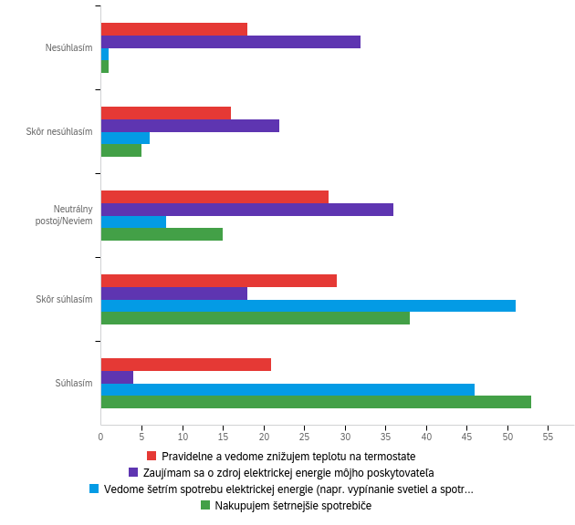

Data source misconfigured for this visualization

Data source misconfigured for this visualization